Physics Exercise
Writing Procedural Account (pre-instruction task)

Name:________________________ Marks:_________
Class: ____ Class number: ____
(Adapted from CE 2005 Physics Paper 1 Q.6)
You are provided with the apparatus in Figure 1.
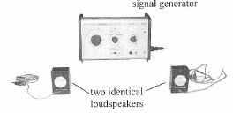
Figure 1

Describe how you should use the apparatus to conduct an experiment to measure the wavelength of the sound wave in air. You may use additional apparatus if necessary.
___________________________________________________________________
___________________________________________________________________
___________________________________________________________________
___________________________________________________________________
___________________________________________________________________
___________________________________________________________________
___________________________________________________________________
___________________________________________________________________
___________________________________________________________________
___________________________________________________________________
___________________________________________________________________

