**Physics Exercise**

**Writing Procedural Account WS3 Attachment**

CE 2006 Paper 1 Q.7

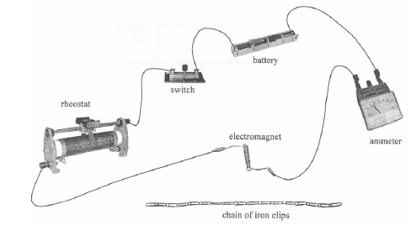

Figure 1

In a physics lesson, you are asked by the teacher to investigate the relationship between the strength of an electromagnet and the number of turns of its coil by using the apparatus shown in Figure 1. Describe the procedure for the experiment you should conduct. State clearly how you can measure the strength of the electromagnet.

**Answer**

First, using the electromagnet, lift up one end of the chain of iron clips slowly and vertically. Just before the chain falls, count the number of clips being lifted up by the electromagnet, which represents the strength of the electromagnet. Repeat the above steps with different numbers of turns in the coil and record respectively the number of clips lifted up by the electromagnet just before the chain falls. The current is kept constant in every trial by adjusting the rheostat.

CE 2007 Paper 1 Q.8

In a physics lesson, a teacher uses the apparatus shown in Figure 2 to find the range of α particles in the air. Describe the procedures of the experiment.

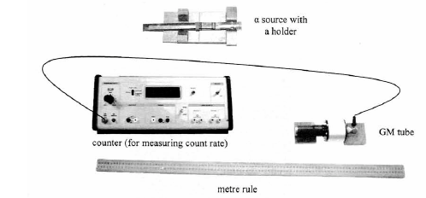

Figure 2

**Answer**

Align the α source with the GM tube with the two objects facing each other. Vary the separation between them and observe the count rate reading. Mark the position where rapid change in the count rate is observed. Measure the distance between the α source and the GM tube with the metre rule. This represents the range of α particle in air.

CE 2010 Paper 1 Q.3

Describe how to use the apparatus as shown in Figure 3 to conduct an experiment to demonstrate the convection of air current.



Figure 3

**Answer**

Light up the candle with the lighter and put it over the glass on one side of the separating cardboard. Then put the lighted joss stick inside the other side of the glass. Observe the movement of the smoke from the joss stick, which is drawn through the bottom of the separator and rise up on the side of the candle. This movement of the smoke demonstrates the convection of the air current.