**Physics Exercise**

**Writing Procedural Account WS4 Attachment (Group Task)**

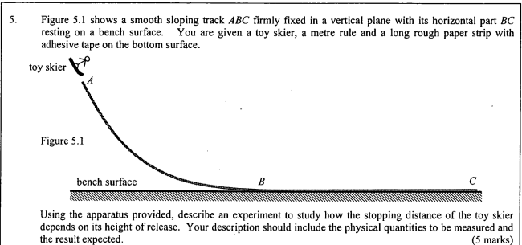

**Sample Answer A**

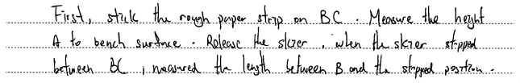

**Sample Answer B**

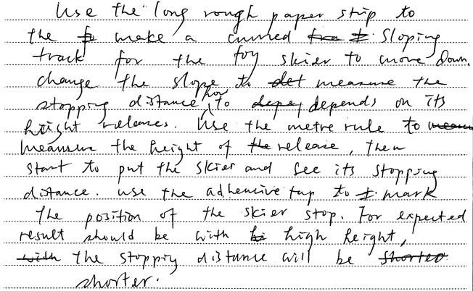

**Sample Answer C**

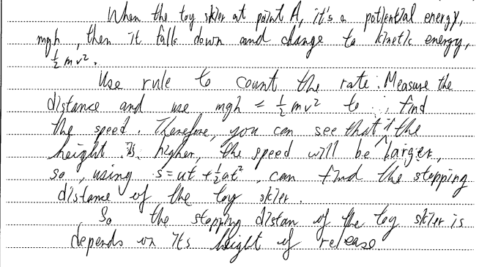

**Sample Answer D**

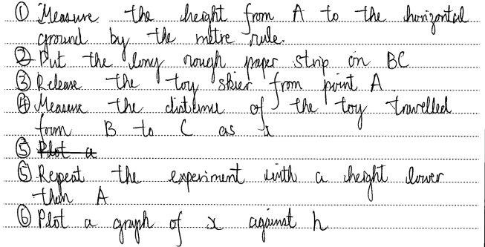

**Sample Answer E**

