物理作業

程序記述寫作 (教學前作業)

姓名: ________________________ 分數: _________
班級: ____ 班號: ____
(修改自CE 2005 物理 卷一 題6)

給你圖1的設備。
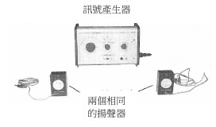
圖 1

試描述你如何利用這些設備去進行一項實驗，量度空氣中聲波的波長。如有需要，你可以使用額外的設備。
___________________________________________________________________
___________________________________________________________________
___________________________________________________________________
___________________________________________________________________
___________________________________________________________________
___________________________________________________________________
___________________________________________________________________
___________________________________________________________________
___________________________________________________________________
___________________________________________________________________
___________________________________________________________________

