MINI OFFCIAL
SCRABBLE LIST

2 LETTERS – WORDS

AA AD AE AI AR AW AX AY CH

EA EE EF EH EL EM EN ES EX

FY GI GV ID IO JO KA KO KY

NY OB OD OE OI OM OO OS OV

OW OY PH QI SH ST TA TI VG

UM UN UR UT XI XV YU ZO
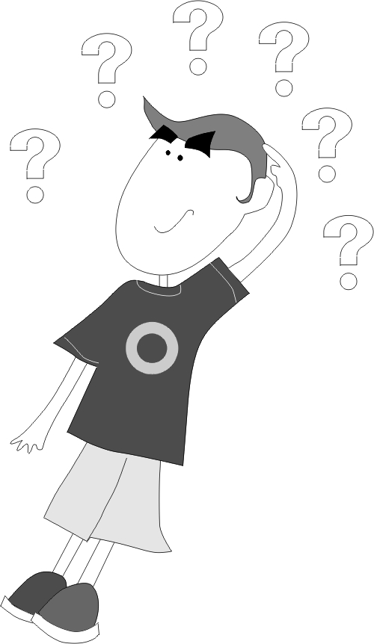

3 LETTERS-WORDS LIST

AAS | ABA | ABB | ABY | ACE | ADD | ADO | ADS | AHA | AIA | AID | AIM
AKE | ANA | ANN | ANT | AUK | AUA | AVE | AWE | BIT | BOS | BOT
CAB | CHE | CHI | CID | COD | COO | COS | COW | CUD | CUM | CUR | DAD
DAK | DIP | DIT | DOC | DOS | DOT | DVE | DYE | ECO | EEK | EEE | EEL
EEN | ELK | ENG | ERR | ESS | EST | EVE | FAD | FAP | FED | FEE | FET
FLE | FOU | FRY | FUB | FUD | FUG | FUM | FUR | GAE | GED | GEE | GEL
GEM | GEN | GEO | GET | GEY | GIO | GOO | GUE | HAE | HEM | HEN
HEP | HER | HES | HET | HEW | HEY | HOE | HUE | ICE | ICH | IDE | IFF
ILL | INN | IRE | JEE | JET | JEU | JEW | JOE | KAE | KEA | KEB | KED | KEG
KEN | KEP | KET | LED | LEE | LEG | LEE | LEK | LES | LET | LEU | LEV | LEW
LIE | MAM | MEG | MEL | MEN | MES | MET | MEU | MEW | MOE | NAE
NAN | NER | NED | NEE | NEF | NEK | NET | NEW | NIE | NOX | NOY
NTH | NYE | NYS | OAK | OBO | OCA | OHM | OKE | OMS | OOS | OPT
ORB | OUK | OVA | OWT | OYE | OYS | PAH | PAM | PAP | PAW | PAX
PHI | PHO | PHS | PIP | PIU | PIX | PLY | POW | POX | POZ | PRO | PST
PUP | PUS | PYE | PYX | QAT | AIS | QUA | RAJ | RAM | RAW | RAX | RAT
REM | REN | REV | REX | REZ | RHY | RIZ | ROM | RUB | RUG | RUM | RYA
RYE | SAG | SAI | SAL | SAM | SAX | SAZ | SED | SEN | SEZ | SIC | SIP | SIS
SOS | SOU | SOV | SUY | TAE | TAJ | TAW | TAY | TEE | TEF | TIT | TOT | TUI
TUT | TUX | TWA | TWP | TYG | TSK | UDC | UDS | UEY | UFC | ULE | URD
UTS | UTU | UVA | VAC | VAE | VAU | VEE | VEF | VEG | VIE | VIM | VIN
VIS | VLY | VOE | VOL | VOR | VUG | VUM | WAD | WAE | WEE | WEM
WHA | WOE | WOG | WOK | WOP | WOS | WUP | WUS | WTN | YAH
YAK | YAM | YAP | YEA | YEN | YEW | YGO | YOB | YOD | YOK | YOS | YUG
YUS

The Big Five "J"

2 LETTER | 3 LETTER | 4 LETTER | 7 LETTER | WORDS WITH "J"
JO | JAB | JACK | JERBOAS | GJU
 | JAK | JAKE | JANGLED | HAJ
 | JAP | JAMB | JANGLER | RAJ
 | JAY | JANE | JASMINE | TAJ
 | JEE | JANN | JANTIER | AJEE
 | JEU | JAPE | TAJINES | BAJU
 | JIB | JARL | RAMJETS | BENJ
 | JIG | JASS | JIRBLES | DOJO
 | JIZ | JATO | JOISTED | GAJO
 | JOE | JAUP | JERRIES | GJUS
 | JOG | JAZY |  | HADJ
 | JOR | JEED |  | HAJI
 | JOT | JEEL |  | HAJJ
 | JOW | JEFF |  | MOJO
 | JUD | JEUX |  | PUJA
 | JUS | JIAO |  | RAJA
 | JUT | JIFF |  | ROJI
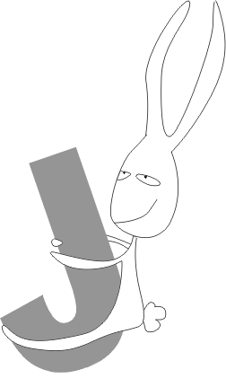
JINK
JIMP
JINX
JIVE
JIZZ
JOCO
JOEY
JOHN
JOKY
JOMO
JOOK
JOUK
JUJU
JUKE
JUVE
JYNX

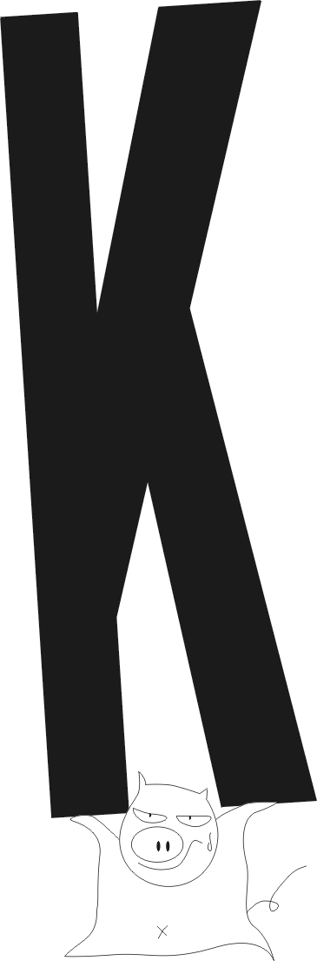The Big Five "K"

2 LETTER | 3 LETTER | 4 LETTER
KA | KAS | ASAK
KY | KEF | AMOK
 | KEG | BIRK
 | KEX | BURK
 | KQA | CAKY
 | KOW | CHIK
 | KYU | DHAK
 |  | ESKY
 |  | FUMY
 |  | FYKE
 |  | JOKY
 |  | KAGO
 |  | KAMA
 |  | KANA
 |  | KAVA
 |  | KAWS
 |  | KAZI
 |  | KEFS
 |  | KERB
 |  | KHUD
 |  | KIPP
 |  | KIVA
 |  | KIWI
 |  | KNEW
 |  | KOHL
 |  | KYLE
 |  | KYUS
 |  | SKAG
 |  | UKES
 |  | YELD

The Big Five "Q"

2 LETTER | 3 LETTER | 4 LETTER | 5 LETTER | 6 LETTER | 7 LETTER
QI | QAT | AQUA | SQUAD* | QUAKED | QUADRAT
 | QIS | QADI* | SQUAT | QUAKER | QUAHAUG
 | QUA | QATS | QUAYD | QUALMY | QUASHEE
 | SUQ | QOPH* | QUEYN | EQUANT | QUETZAL
 |  | QUAG* | EQUID | QUANTA | QUEBBLE
 |  | QUAD* | SQUID | QUARER
 |  | QUAT* | QUINA | QUARTE
 |  | QUEP | QUINE | QUARTO
 |  | QUEY* | QUINT | QUARTZ
 |  | QUID* | EQUIP | SQUASH
 |  | QUIM* | QUIPO | QUEENY
 |  | QUIN* | QUIPU | QUEMED
 |  | QUIP* | SQUIT | QUICHE
 |  | QUIZ | SQUIZ | SQUIEF
 |  | QUOD* | QANAT* | SQUILL
 |  | QUOP* | QIBLA*
 |  | SQUS | QUACK*
 |  | WAQF | QUAEF*
 |  |  | QUAIL*
 |  |  | QUAIR*
 |  |  | QUAKE*
 |  |  | QUALM*
 |  |  | QUANT*
 |  |  | QUARE
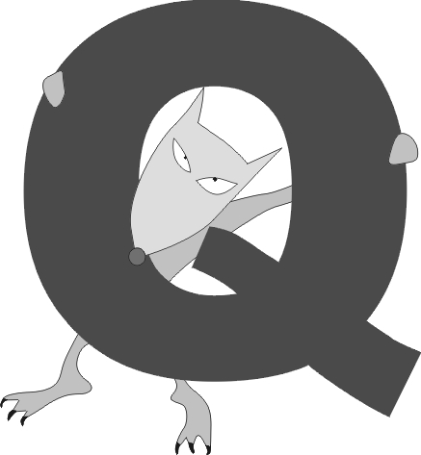
QUARK*
QUART*
QUASH
QUEAN*
QUELL*
QUEME*
QUENA*
QUERN*
QUEYN*
QUICH*

The Big Five "X"

2 LETTER | 3 LETTER | 4 LETTER | 5 -6 LETTER | 7 LETTER
AX | COX | AXON | CHOVX | ANTHRAX
EX | DUX | CALX | XYLIC | XIPHOID
OX | HOX | EAUX | BOYAUX | RESEAUX
XI | KEX | EXUL | MENINX
XU | LEX | FAUX | XOANON
 | MUX | FLUX
 | PAX | IBEX
 | PYX | IXIA
 | RAX | LYNX
 | SOX | MINX
 | TUX | MIXT
 | VEX | MOXA
 | VOX | ONYX
 | WEX | PREX
 | XIS | ROUX
 | YEX | SEXT
 | ZAX | VLEX
 |  | WEXE
 |  | XYST
 |  | YUNX

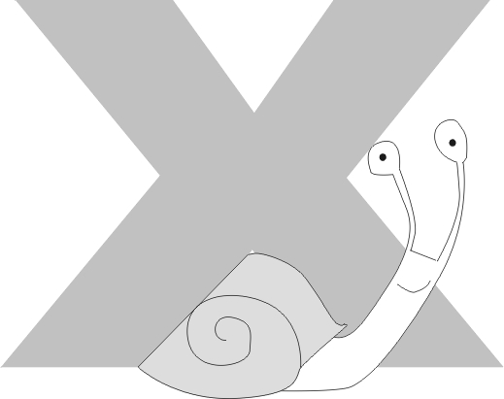

The Big Five "Z"

2 LETTER | 3 LETTER | 4 LETTER | 5 LETTER | 6 LETTER | 7 LETTER | 8 LETTER
ZO | ADZ | COZY | AIZLE | AMAZON | BAZOOKA | HOLOZOIC
 | BEZ | CZAR | CLOZE | BAZZAR | ANALYZE | ZILLLION
 | DZO | CHEZ | DIAZO | HAZARD | UTILIZE
 | MIZ | DZHO | FEEZE | ZODIAC
 | REZ | OOZE | GAZOO
 | SAZ | PHIZ | HAZEL
 | ZOA | SWIZ | TOPAZ

 |  | WHIZ | IZARD
 |  | ZEIN | SEIZE
 |  | ZINC | RAZOR
 |  | ZITI | WALTZ
 |  | ZULU | ZONAE
 |  | ZOEA | ZAIRE

6 Letters + 1 Letter

RAINED | RETAIN | SATINE | SATIRE | TORIES
BRAINED | CERTAIN | SAINTED | ASTERIA | EDITORS
DEARING | TRAINED | STAINED | RACIEST | STORIED
GRAINED | JANTIER | EASTING | DIASTER | GOITRES
READING | TRAINER | TEASING | DISRATE | HOISTER
HANDIER | RATINES | INTAKES | AIRLEST | LOITERS
DRAINER | RETINAS | MAINEST | REALIST | MOISTER
RANDIER | NITRATE | NASTIRES | ARTIEST | ORIENTS
TRAINED | TAURINE | VAINEST | TASTIER | ROOTIES
INVADER | URINATE | WANTIES | WAITERS | STORIES
 | TINWARE | ZANIEST | PIRATES

