BAFS Elective Part - Business Management Module – Marketing Management
Topic M06: Role of Marketing

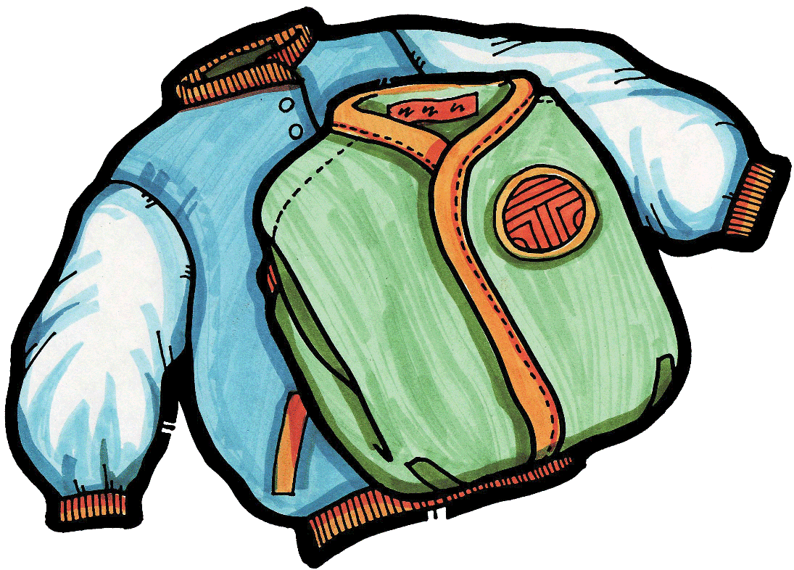

Activity 1: Opening a Japanese Trendy Shop – Roland needs your advice

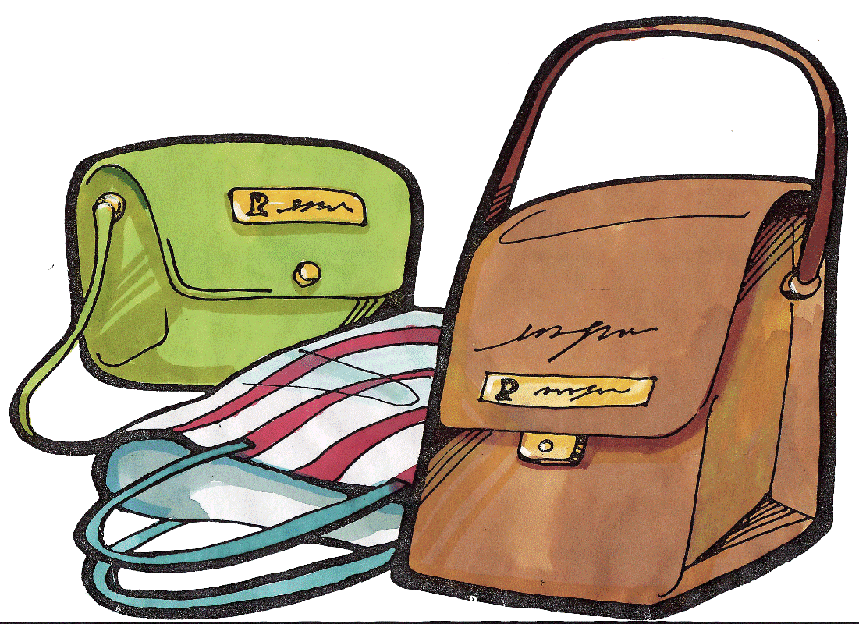

Roland is 20 years of age. His sister, Eva, is a designer for a Japanese company in Hong Kong.

Both Roland and Eva have been very interested in Japanese trendy products such as name brand T-shirts, bags and games.

Recently, Eva married a Japanese national in Hong Kong and will be relocating permanently to Japan. Seizing this great opportunity, Roland and Eva decided to open a Japanese trendy shop in Hong Kong.

Eva will be responsible for sourcing trendy Japanese products and Roland will be responsible for the Hong Kong operations. Roland asked his father for financial assistance. Before making any decision, his father asked them a question:

“Although you have good products from Japan, what is your plan to promote your shop and products?” | 

Roland has not studied business management courses. He needs your advice!

Write your suggestion in the space provided below:

1.
2.
3.
Activity 3: What are their market segments?

Name TWO brands in the following product markets and describe their targeted market segments.

Product Markets | Brand 1 and its target market segment | Brand 2 and its target market segment
Newspapers
Mobile telecom services provider
Fashion retailing
Shampoo

