BAFS Elective Part — Business Management Module — Marketing Management
Topic M08: Customer Behaviour

Activity 1: Categorisation of Consumer Buying Decisions

Categorise the following products or services into three types of buying decisions. Each buying decision category has 5 products and/or services.
- Category 1: It requires little time and effort to make a buying decision.
- Category 2: It requires a moderate amount of time and effort to make a buying decision.
- Category 3: It requires a considerable amount of time and effort to make a buying decision.

Product/Service | Category 1 | Category 2 | Category 3 | 
1. Fruits   | ❑ | ❑ | ❑
2. Candies | ❑ | ❑ | ❑
3. University Courses | ❑ | ❑ | ❑
4. Computers   | ❑ | ❑ | ❑

Product/Service | Category 1 | Category 2 | Category 3 | 
5. Facial Services | ❑ | ❑ | ❑
6. Cosmetic Surgeries | ❑ | ❑ | ❑
7. Sports Shoes   | ❑ | ❑ | ❑
8. Reference Books | ❑ | ❑ | ❑
9. Houses   | ❑ | ❑ | ❑
10. Tissue Packs | ❑ | ❑ | ❑
11. Soft Drinks   | ❑ | ❑ | ❑

Product/Service | Category 1 | Category 2 | Category 3 | 
12. Cars  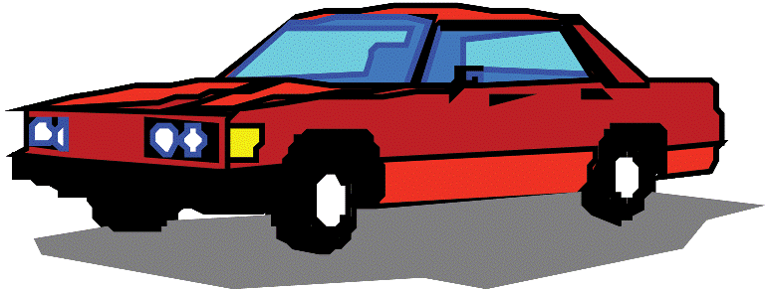 | ❑ | ❑ | ❑


Activity 2: Brainstorming

- Think about two unsatisfied needs you have --- one at a very low cost and one at a high cost.

(1) An unsatisfied need at a very low cost:
_______________________________________________________________

(2) An unsatisfied need at a high cost:
_______________________________________________________________

- Are the buying decision processes of the above 2 items different? How?
___________________________________________________________________________________________________________________________________________________________________________________________________________________________________________________________________________________________________________________________

Activity 4: Case Study
Factors Affecting Consumer Behaviour
Jeffrey and Jennifer married young and have no children. They both have satisfactory income and bought an apartment in Tai Koo Shing with a 70% mortgage loan with a bank. Jeffrey was timid but he liked driving a powerful car. Jennifer had a strong need for accomplishment and esteem and she liked competitive activities such as sports.


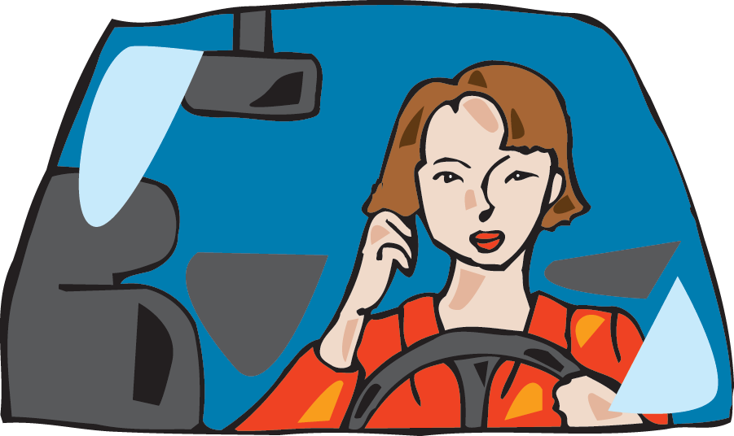

Question 1
From a consumer behaviour perspective based on psychological factors, why would timid people, like Jeffrey, desire to drive a powerful car?
_____________________________________________________________________________________________________________________________________________________________________________________________
Question 2
(a) From a consumer behaviour perspective, in relation to psychological factors, why do consumers, like Jennifer, participate in competitive activities like sports?
(b) You were a marketing manager for health supplements, what advertising “slogans” would you use (just two or three words) to attract this type of consumers who participate in “swimming” and “biking”?

(a)____________________________________________________________________________________________________________________________
(b)_____________________________________________________________


For years, Jeffrey and Jennifer have been health conscious. For example, they consume Perrier bottled water at home. The economic growth has been steady over a decade that has enhanced the purchasing power of consumers like Jeffrey and Jennifer and the sought status. For example, they often bought luxury goods such as Rolex watches and LV handbags.
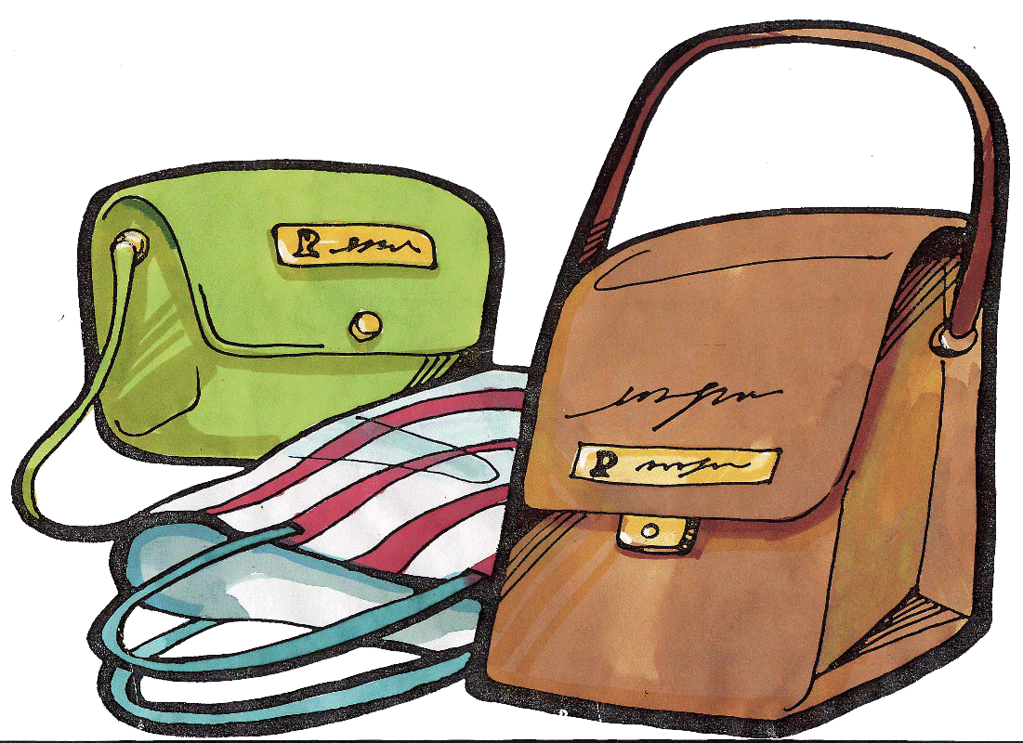

Rolex LV Perrier

Question 3
Again from a psychological viewpoint, why do consumers, like Jeffrey and Jennifer, buy an item that can be worth virtually nothing — like water? (Hints: Water is inexpensive from municipal agencies, yet millions of consumers now pay 1,000 times the price of municipal water to purchase bottled water.)
______________________________________________________________________________________________________________________________ _______________________________________________________________
_______________________________________________________________

Question 4
It is often said that a person’s economic situation will affect their product choice. If you were the Rolex marketing manager and the economy is prosperous, how would you position Rolex and which segment would you target?
_____________________________________________________________________________________________________________________________________________________________________________________________


The economic impacts of the COVID-19 pandemic in 2020 to 2022 reduced the earnings of many people. Many retail shops shut down and many people in Hong Kong had salary cut.


Jennifer’s accounting firm cut her salary by 15% and gave her an extra ‘no-pay-leave’ each week as ‘compensation’. Due to the weak economy, Jeffery was laid-off from a large HK telephone company. In fact, many people, like Jeffrey and Jennifer, who were victimised by the COVID-19 pandemic with salary cut. . They sold their powerful car, for the sake of saving money on gasoline and car-park. Unlike their previous buying behaviour, they began purchasing goods and services based on utility (rather than pleasure or social class).
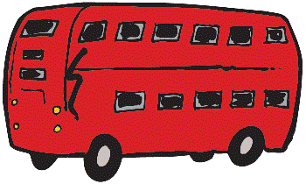
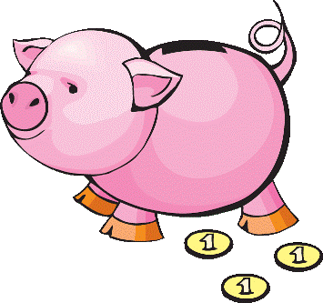
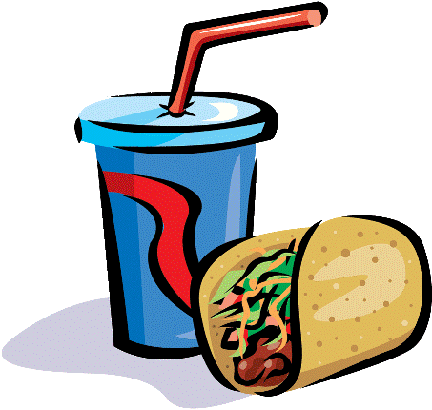

Question 5

- Name one industry in Hong Kong which could make money during the COVID-19 pandemic. Why?
Example 1 _____________________________________
Reason: _____________________________________________________________________________________________________________________________________________________________________________________________

- Name one industry in Hong Kong which experienced loss during the economic downturn. Why?

Example 2 _____________________________________
Reason:
_____________________________________________________________________________________________________________________________________________________________________________________________

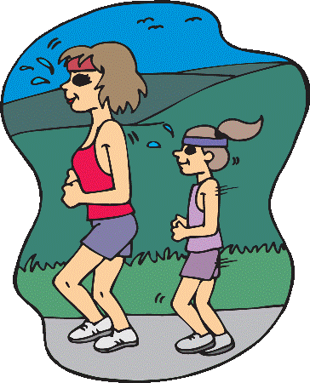
After one year of tough times, Jeffrey found a new job with an international market research firm. He was required to collect, analyse, and interpret research data and then recommend solutions for the marketing problems that the clients faced. Jeffrey’s research colleagues received a contract from a large international sportswear firm and collected the following research data from different countries:
Research Data on Participating in Sports and Exercise in Different Countries
(Cross-Cultural Variations in Consumer Behaviour)
Mean Number of Hours Physical Exercise Per Week – Men & Women
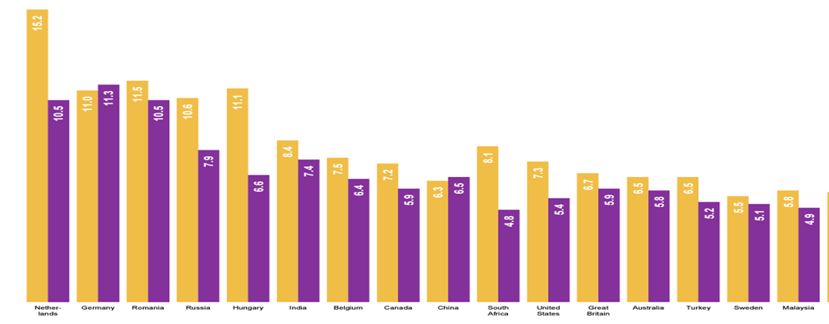
(https://www.ipsos.com/sites/default/files/ct/news/documents/2021-08/Global-Views-on-Sports-and-Exercise-Ipsos.pdf )
Question 6
Based on cross-cultural variations in the different countries, what marketing strategies would be appropriate for the clients?
_____________________________________________________________________________________________________________________________________________________________________________________________
Activity 5: Case Study
Kids’ Paradise is a child friendly restaurant with a massive indoor play area and restaurant, located in two districts in Hong Kong. The playrooms feature a huge ball pit, a race track, and slides.
On Sundays, children can enjoy free face painting and balloon twisting. While kids are being entertained, the parents can enjoy an array of selection of Korean, Taiwanese and Japanese dishes as well as continental ones like spaghetti and meatballs.
As a new attraction, Kids’ Paradise plans to hold special workshops and shows regularly at weekends. Besides, Food & Fun will also offer a new kids’ menu that includes a fun DIY pizza option, allowing children to select their favorite toppings and create their own pizzas.
- Using catering services embedded with kids playgrounds, describe the steps in the consumer buying decision process
__________________________________________________________
__________________________________________________________
__________________________________________________________
__________________________________________________________
__________________________________________________________
__________________________________________________________
__________________________________________________________
__________________________________________________________
__________________________________________________________
__________________________________________________________
__________________________________________________________
- Explain two socio-cultural factors affecting the buying decisions of Food & Fun’s customers
__________________________________________________________
__________________________________________________________
__________________________________________________________
__________________________________________________________
__________________________________________________________
__________________________________________________________
__________________________________________________________
__________________________________________________________
Activity 6: Differences between Business Markets and Consumer Markets
Differences in |  | Consumer Market | Business Market
- Complexity of buying decisions | - Professionalism of Buying
- Complexity of buying decisions | - Product Complexity
- Complexity of buying decisions | - Buying process
- Nature of demand | - Number of Buyers
- Nature of demand | - Size of Buyers
- Nature of demand | - Demand is derived from
- Relationship between buyer & seller | - Supplier-customer Relationship
- D. Price sensitivity of buyers | - Elasticity of Demand
Activity 7: Debate


“Business marketing is the same as consumer marketing”


For the affirmative side, write down the “for” arguments of the proposition.
For Arguments:

1. ____________________________________________________
____________________________________________________
____________________________________________________
2. ____________________________________________________
____________________________________________________
3. ____________________________________________________
____________________________________________________
____________________________________________________
4. ____________________________________________________
____________________________________________________
5. ____________________________________________________
____________________________________________________
____________________________________________________
6. ____________________________________________________
____________________________________________________
For the opposition side, write down the “against” arguments of the proposition.

Against Arguments:

1. ____________________________________________________
____________________________________________________
2. ____________________________________________________
____________________________________________________
____________________________________________________
3. ____________________________________________________
____________________________________________________
____________________________________________________
4. ____________________________________________________
____________________________________________________
5. ____________________________________________________
____________________________________________________
____________________________________________________
6. ____________________________________________________
____________________________________________________
____________________________________________________

