Business, Accounting and Financial Studies
Compulsory Part 1(b) Introduction to Management: Management Functions
Lesson 1: Role and importance of Management
Activity 1 - Class Discussion
Can you suggest any company goals of an online game development company to achieve? Suggest three goals and write in the space provided.



Activity 2A - Matching
In what way do you think different managerial levels can help an online game development company operate? Match the roles and duties on the right with the correct management level on the left.
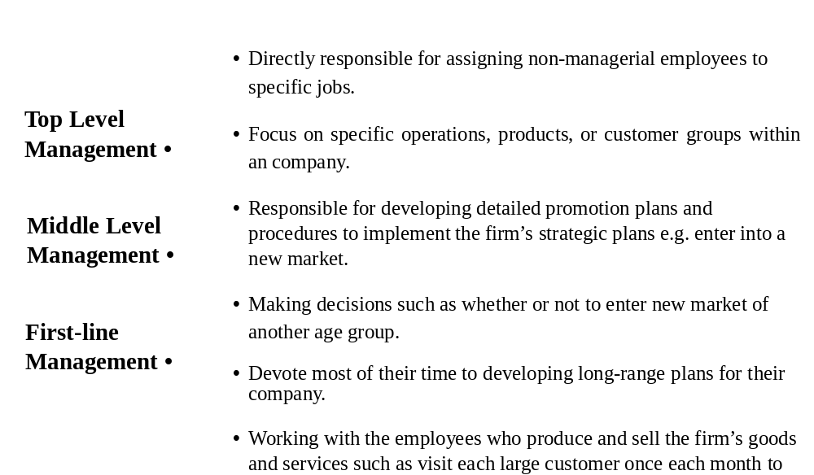



Activity 2B - Case Study
Identify the three managerial levels in a secondary school and list the roles and duties at each level in the table below.

Level |  | Position/Title | Roles/Duties
Top |  | Principal
Middle |  | Department/  Division Heads
First-line |  | Panel/Subject  Heads



Activity 3 – Class Discussion
Identify the managerial role performed in each of the following activities. Write your answers in the space provided.
- Training
- Budgeting
- Hold meetings
- Organising resources to develop new product
- Hold press conference
- Performing activities that involve outsiders

Role | Activities
Decisional

Informational

Interpersonal


Business, Accounting and Financial Studies
Compulsory Part 1(b) Introduction to Management: Management Functions
Lesson 2: Planning
Activity 1 - Class Discussion
Part (a)
- Students are divided into groups of 4. Assume that each group will have $1,000,000 to start up a business.
- Discuss in groups and decide what business your group is going to start up and then set the company goal. Write your decision on the cue card provided by teacher.

Part (b)
Pass your cue card to the next group. Now each group should evaluate the goal set by another group and decide whether it is a SMART goal.



Activity 2 - Class Discussion
You are the manager of the online game developing company. The goal of the company is to obtain 20% market shares in the industry.
Each group should discuss and draft a plan for the company by completing the table below.
Name of the online game developing company
- Company goals
- Alternative strategies for achieving goals
- Best way selected in (2)
- Short term plan
- Plans to action

Business, Accounting and Financial Studies
Compulsory Part 1(b) Introduction to Management: Management Functions
Lesson 3: Organising
Activity 1 - Group Discussion
Discuss in groups why organising function is important to a company.


Activity 2 – Design an Organisation Chart
Suppose you want to set up a new business with your friends. Decide the product you would like to sell as well as the target customers. Design the organisation chart of your business and draw it in the space provided

Explain why the above organisation chart is appropriate for your business.

Business, Accounting and Financial Studies
Compulsory Part 1(b) Introduction to Management: Management Functions
Lesson 4: Leading
Activity 1 - Class Discussion
Can you describe the characteristics of a good leader like the former Chairman of Apple Computers Inc., Steve Jobs? List at least 5 characteristics of a good leader in the space provided.


Activity 2 - Group Discussion
Which leadership style should be adopted by the management in the following situation? Briefly explain your answer.
- A newly recruited employee who is expected to pick up work in short time, the manager is being a coach to direct him in work.
- The existing project team who knows their job well and does not require too much instruction. The manager simply let the team make their own decision and provide feedback when they need help.
- An employee who is the expert of his job and knows more about the job than the manager. There is no need for the manager to give instruction and the employee is free to make his own decision at work.

Situations | Leadership Styles | Reasons
1.
2.
3.


Business, Accounting and Financial Studies
Compulsory Part 1(b) Introduction to Management: Management Functions
Lesson 5: Controlling
Activity 1 - Group Discussion
A restaurant wants to improve the service provided to its customers. One of the targets is to reduce the waiting time for serving the food after the customer places an order.

Design a controlling system to measure the efficiency of service and customer satisfaction.

Step | Action

Activity 2 - Class Discussion
You have just been employed as the manager of a local fast food shop. You are reviewing the management tasks ahead and aware that they belong to one of the four major management functions. Put a ‘✓’ in the correct boxes to indicate the management function that the following activities are performing.

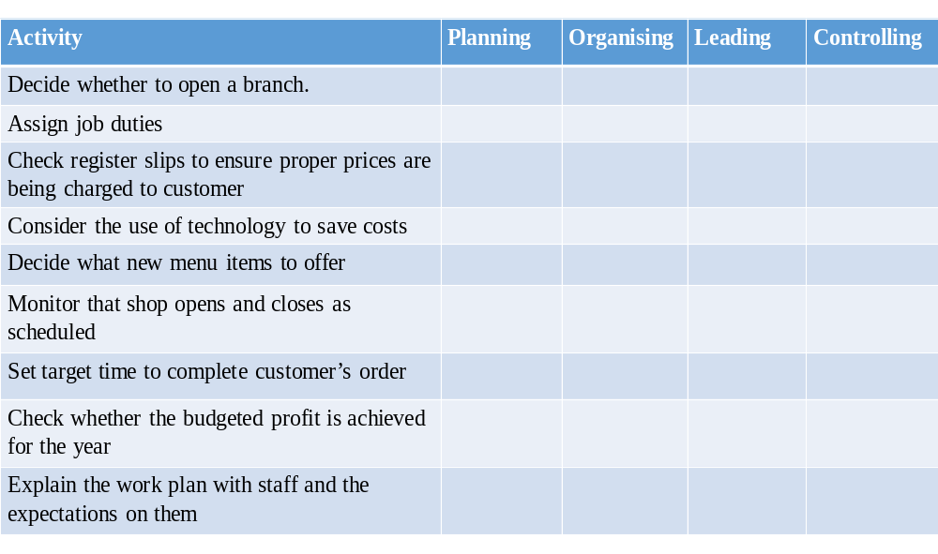

Business, Accounting and Financial Studies
Compulsory Part 1(b) Introduction to Management: Management Functions
Lesson 6: Effectively Management
Activity 1 – Class Discussion
1. Name a kind of business you would like to do.

2. List the job positions in such business.

3. Is there any division of work in the business? Explain your answers.

Activity 2 – Class Discussion
Alan and Benny are the owners of a boutique with 3 sales staff. Both Alan and Benny could give orders to the 3 staff. One day, Alan instructed Charles, one of the sales staff, to check stocks but at the same time Benny asked him to serve customers.

Are there any problems when there are two supervisors for one subordinate? Explain your answer in the space below.



Activity 3 – Group Discussion
The objective of ABC Limited is to reduce the production cost by 5% this year. The production manager is therefore thinking about how to achieve this goal. He tells the supervisor to enhance the quality assurance procedure to reduce scrap rate and the waste of materials. He also asks the merchandiser to negotiate the price with suppliers or to reschedule the buying practice to obtain a bulk order discount.

Describe the unity of command and unity of direction in this case.

 | Unity of Command | Unity of Direction
Principle

Application



Business, Accounting and Financial Studies
Compulsory Part 1(b) Introduction to Management: Management Functions
Lesson 7: Authority & Responsibility
Activity 1 - Class Discussion
You are the manager of ABC Ltd with a flat organisational structure having one manager supervising six subordinates. Currently your company is thinking to re-design the organisational structure with a view to improving the operation efficiency. What are the factors affecting span of control? Suggest three factors with explanation.

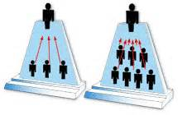
Activity 2 – Group Discussion (Extended Task)
You are the General Manager of a multinational company. The company has more than 15,000 employees over 150 locations in the world. There are 10 Regional Managers to oversee the operations of each location and they report to you through videoconference.

How can you manage this company?

[In your answer, you can discuss the challenges of managing a virtual team and how you can handle these challenges.]
Challenges:

Strategies:



Business, Accounting and Financial Studies
Compulsory Part 1(b) Introduction to Management: Management Functions
Lesson 8: An Integrated Activity – Planning for a 3-hour Talent Show
Background:

- Your school is going to arrange a 3-hour talent show at the end of this semester.
- The budget for this event is $5,000.
- This talent show serves the following purposes:
- Provide a fun, family event that brings the entire school together
- Provide an opportunity for the students to cultivate their performance skills
- Develop students’ sense of belonging
- Enhance communication between teachers and students
- You have been invited to join the organising committee of the event.


Activity 1 – Group Discussion
You are required to discuss with your committee members to design the work schedule and determine the resources required.

Date | Tasks

Resources required:

Activity 2 – Group Discussion
You are required to design the organisation chart for this event. You have to determine how many members are required and assign their roles and job duties. Write your answer in the space provided.

Title/Post | Roles/Duties
e.g. Chairman | Manage the coordination and invite judges for the event.

Organisation Chart:



Activity 3 – Group Discussion
You have to consider how to direct and motivate student helpers to assist various tasks. Which leadership style is suitable in this case? Explain your answer in the space provided.


Activity 4 – Group Discussion
You are required to develop a method to monitor the progress of the action plan and evaluate the event afterwards.

Progress | Monitor Method
e.g. Enrollment | Set application deadline and maximum of participants.


Activity 5 – Group Discussion

Read the following scenarios and suggest an appropriate management principle to be applied to resolve the problem incurred in each case.

Scenario 1
To prepare for the talent show, each team member has his/her specialised duties as per the organisation chart.

Simon and Mary are the committee members and they are responsible for the Venue & Logistic, and Programme respectively.

During the show time, Simon asks John, the student helper for photo and video-taking, to take photos of the venue setting. At the same time, Mary also asks John to take video of the performance. John is therefore confused about his duty because he faces the dilemma of “who’s order he should follow?” at that time.

Question
Suggest an appropriate management principle to apply to this scenario. Explain your answer.

Scenario 2
One of the objectives of the talent show is to provide equal opportunity for all participants to show their talent by performing in the show. The chairman is therefore thinking about how to achieve this goal. He tells the registration committee to make sure that each performance does not exceed the individual time allotment and, further, that the performance should be suitable for family audience. He also asks the programme committee to prepare the programme rundown and control the time of each performance.

Question
Suggest an appropriate management principle to apply to this scenario. Explain your answer.



