Learning Objectives
- To know what money is.
- To understand features of different finance products.
- To understand the importance of maintaining a good personal credit record.

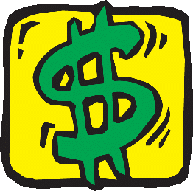

What is money?
Have you ever played Monopoly? At the beginning of the game, every player will receive some money notes.
Can you tell me the uses of money in Monopoly?
- To buy property
- To pay for the penalty
- To build house
- Etc.


We always use money to buy things. Money serves as a medium of exchange. It can be used for making payments or settling debts. Have you ever taken a close look at the bank note? Let’s take out a $10 note.

1. Who prints $10 note?
- The Hong Kong Special Administrative Government
2. What is the colour of a $10 note?
- Purple

3. Can you name the banks which also serve the issuance of bank notes in Hong Kong?
- The HSBC, the Bank of China, the Standard Chartered Bank
4. What are the colours of other bank notes?
- ($50) green or purple; ($100) red; ($500) brown; ($1000) gold
5. Other than bank notes, what other kinds of money are used in Hong Kong?
- Coins
6. Can you list all the coins we have in Hong Kong?
- $10, $5, $2, $1, 50 cents, 20 cents, 10 cents

When issuing bank note, what do the note-issuing banks (NIBs) need to stipulate?

Authorization is accompanied by a set of terms and conditions agreed between the Government and the three note-issuing banks (NIBs). Bank notes are issued by the three banks, or redeemed, against payment to, or from, the Government Exchange Fund in US dollars, at a specified rate of US$1 to HK$7.80 under the Linked Exchange Rate system. (Source: Hong Kong Monetary Authority)
Challenging Question 1

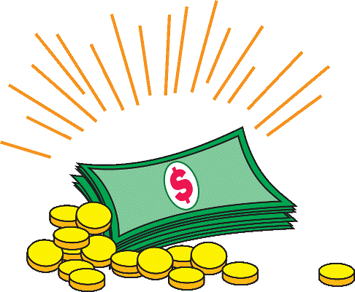

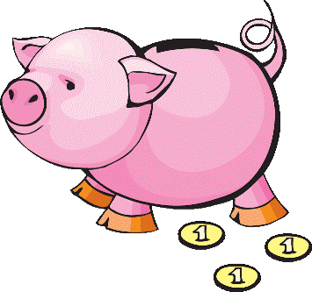
Saving money

In Chinese culture, children receive red packet during the Lunar New Year, which represents good luck in the coming year. Instead of putting the money in the piggy bank, where can the children put their money?

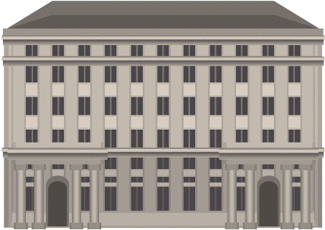

Children can save money in the bank. Depositing money in the bank savings account will help the money earn more money. Do you know why?
ABC Bank

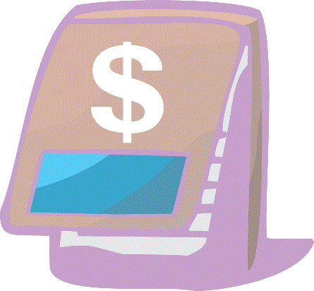
Saving money in the bank can earn interest. Interest is the amount of money that the bank pays you when they use your money. The bank uses the money to make loan to other people or business. When you deposit your money in the bank, the bank will issue you a bank book or bank statement and tell you how much money is in your savings account. The interest earned is also shown.

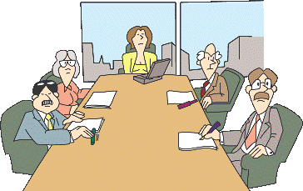

Survey
The aim of the survey is to let students gain an understanding on their own spending pattern. Form a group of 6 students. Conduct a survey on how they spend money per week.

(Step 1) Fill in the details of spending per week by yourself.

Pocket money per week: ______________________________________________
Item | Mon | Tue | Wed | Thur | Fri | Sat | Sun | Total
Item | $ | $ | $ | $ | $ | $ | $ | $
Transportation  Fees | Different students may have different amount of pocket money every week. To avoid comparison among students, teachers are suggested to let students finish this part individually.
Meals
Books
Stationery
Snacks
Saving
Others

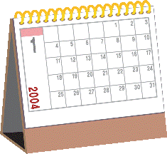
Have you ever set a budget before? A budget will help you think more about how to spend money.

(Step 2) Before sharing with others, calculate the percentage of spending on each item based on the pocket money per week.

Item | Total
Item | %
Transportation fees | Teachers request students to calculate the percentage of spending for ease of comparison.
Meals
Books
Stationery
Snacks
Saving
Others

(Step 3) Compare the percentage spent on different items among classmates. What do you notice?

- Difference in transportation fee due to various distance between home and school
- Different amount of savings
- Some of them may have no spending on meals because they bring along their own breakfast and lunch
- Etc.

(Step 4) Self-reflection

Do you spend money wisely?
- Reasonable answers are accepted.

2. What is money?
- Money is an asset that is generally accepted as a medium of exchange for settling payments or debts.
- Sellers set the prices of goods or services in terms of money.

3. Other than paying by bank notes, can you name some other means for payment?
- Octopus card
- Credit card
- Cheque
- Etc

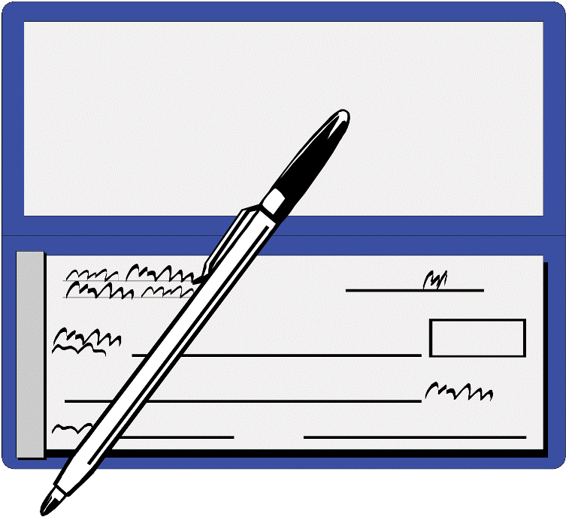
What is a cheque?
Have you ever seen a cheque? Sometimes, schools require you to pay with a cheque for the purchase of books and stationary. Paying with a cheque is easier and safer than carrying “real” money. A cheque is a substitute for cash for settling debts or making payments.

How do your parents get a cheque book?
They need to open a current account in a bank. A cheque book will be given to the holders of every current account. Before issuing a cheque to others, your parents should make sure that they have enough money in the current account.

Components of a cheque
Item | Component
1 | Name of the payee/drawee
2 | Name of the payer/drawer
3 | Amount to be paid (Words)
4 | Amount to be paid (Figures)
5 | Issued date
6 | Signature of the drawer
7 | Account number
8 | Cross mark for crossed cheque
9 | Cheque number
10 | Counterfoil
Activity 1

1. Fill in the blank with suitable item number.

8
1
3
4
5

Biz Bank Limited 基滙銀行有限公司
Hong Kong SAR 香港特別行政區
1 July Year 1
Day 日 Month 月 Year 年
Pay or bearer
祈付 HANDSON PROPERTY 或持票人
HK dollars
港幣 THREE THOUSAND ONLY
HK$3,000.--
BEAUTY FULL CO.

801211 012 455 467861 003
9
7
2
6

2. Matching
- A future date is stated at the time
of issue to withhold payment until
that date.
Open Cheque

Crossed Cheque
- The holder of the cheque can draw
cash from the bank counter.

Post-dated Cheque
- With two parallel lines printed or drawn across.
- Can only be deposited into the account of payee.

Stale Cheque
- Presented to be cashed or deposited at a bank six months or more after the date written on the cheque.

What are the reasons for a company or an individual not successful in honouring a cheque?

Insufficient funds in the current account
Post-dated cheques
No counter-signature when changing of items
Incorrect signature
Discrepancies between words and figures
Stale cheque
Payer’s instruction for termination of payment
Etc.
Challenging Question 2



What is exchange rate?

When you go travelling, you need to exchange the corresponding currency for spending in that country/region, for example, you need to change HK Dollar to RMB for spending in the Mainland. Exchange rate is the market price for which one currency can be exchanged for another. For example, if the US exchange rate for the HK Dollar is $7.75, this means 1 US Dollar can be exchanged for $7.75 HK dollars.

Activity 2

Think of some countries/regions that you may want to visit in this summer. You will spend an estimate of HK$10,000. Mark down their currency rates today and check them again two weeks later to see if there is any difference.

Value of my portfolio
Currency chosen | Currency rate today | How much can you exchange today? | Currency rate two weeks later | How much can you exchange after two weeks?
e.g. US | HK$7.75 | US$1290.32 | HK$7.76 | US$1288.66
Teachers are suggested to let students finish the first part (i.e., the currency rate today), and re-visit this table and finish the last part (i.e., the currency rate two weeks later) after two weeks. Students can base on the findings to complete the following question.

Answer the following question after you finish the previous activity.

Which country do you want to go and why?

Teacher can spend 5-10 minutes to let students share their views.
Students may base on the following views when choosing the country to go:
- The exchange rate is stable and there is no need to bear the fluctuation in currency exchange.
- Whether it is easy to exchange that currency in Hong Kong
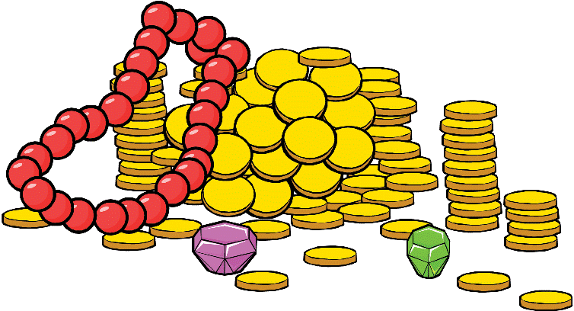
- Any other possible reasons.

Point to note:

Linked Exchange Rate System in Hong Kong
The Hong Kong dollar is officially linked to the US dollar at the rate of 7.8 Hong Kong dollars to one US dollar. The Linked Exchange Rate is the linchpin of Hong Kong's monetary system. It plays an important part in supporting Hong Kong's role as a trading, service and financial centre.
(Source: http://www.info.gov.hk/hkma/eng/classroom/page/work/work_02_01.htm)

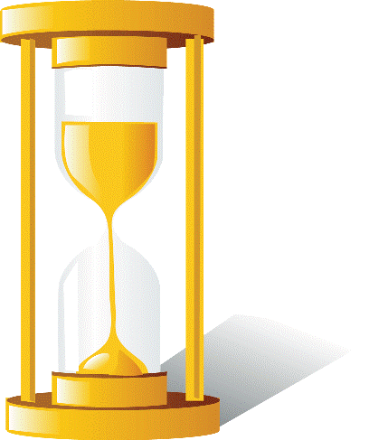

Case Study

Strawberry Store launched a new tablet computer, “Jpad” with a 10” multi-touch screen. As it can install many educational games, Simon, a 13-year-old boy wants to buy one. He discusses with his father about the idea of purchasing a “Jpad”.

Credit card is a type of consumer credits. Let me tell you more later. By the way, how would you pay me back?
Daddy, I’d like to order a “Jpad” online but it only accepts credit card. What is credit card? Can you help me order one?


It’s OK but why?

Daddy, can I pay you by instalment?

I would like to use my savings to buy a new monitor as well.

Haha, it’s OK. But I will charge you interest.

It is easier to search the answers from the Internet. Teachers are suggested to let students finish this part at home.

Class Discussion

Can you help Simon’s father answer Simon’s queries?

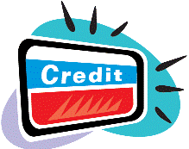
- What is credit card?
- Plastic card authorizing the account holder to charge
purchases against a pre-approved credit line.
- Payable within a grace period (up to 30 days) with no finance charge imposed.
- Teacher can show the real credit card to students.

- What is consumer credit? Can you give some examples?
- Credit is an arrangement to receive cash, goods or services now, and pay for
them in the future.
- Consumer credit is the credit extended to individuals for personal or household use, rather than for businesses.
- Includes all forms of instalment credit other than loans secured by real estate (e.g. home mortgages) and open-end credit such as credit cards.

- What is personal instalment loan?
- A personal instalment loan is a type of unsecured loan to be repaid in fixed instalments.
- The borrower repays the loan principal and interest at fixed time intervals, normally monthly.

- Why interest is charged?

- It is the cost of borrowing and a charge for service.

In this session, we will introduce three major types of personal finance products.
Mortgages

Personal Loans
Credit Cards

What are mortgages?

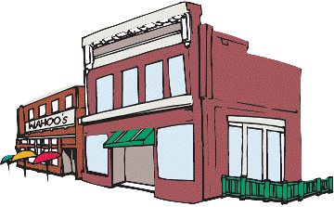
Mortgage is a long-term loan that is used for buying a property only. It is a loan that is secured by real property. Most mortgage loans in Hong Kong are floating rate loans with a fixed payment paying for both principal and interest each month.

There are two common standards used for calculating the interest rate of the loan: (i) a certain percentage above or below the prime rate (usually called “P”); and (ii) a certain percentage above or below the Hong Kong Interbank Offered Rate (usually called “HIBOR “).

Process of buying a property with mortgage

BANK
Property
buyer
Property
Developer/
Owner
Down
payment +
Mortgage
loan
Mortgage
loan
Title of
property
Title of
property
Here is the process of buying a property. Sometimes, buying an apartment involves a large sum of money and many people are not able to pay in full, so they will usually apply for a mortgage loan.

Can you explain the process of buying a property with mortgage using the above chart?

- If the property buyer doesn’t have enough money, he/she will apply mortgage loan from bank.
- The property developer/owner will transfer the title to the property buyer when he/she receives the whole money.
- The whole money includes the down payment (normally 30%) and the mortgage loan (normally 70%).
- The property will serve as collateral until the property buyer repays all mortgage loan.

Case Study

Simon and Denise lived in a flat with a monthly rental fee $8000 after getting married. They are now discussing whether to buy a two-room flat in Kowloon at a cost of HK$3,000,000. Can you help them solve the following questions?

- How much down payment do they need to pay? (Hint: People in Hong Kong usually pay 30% of the purchase price as the down payment.)

HK$3,000,000 * 30% = HK$900,000

- What is the amount of the mortgage loan? (Hint: The bank will help them to pay for the remaining 70%.)

HK$3,000,000 * 70% = HK$2,100,000

- Simon and Denise saved only HK$700,000. Can they buy the flat now? Where can they seek help?

Yes, they can still buy a flat. The Mortgage Insurance Programme (MIP) of the Hong Kong Mortgage Corporation Limited (HKMC) can help.

What are personal loans?

Personal loans are always repaid by fixed instalments. It is a type of unsecured loan. The borrower of the loan repays the principal and interest in equal periodic payments.

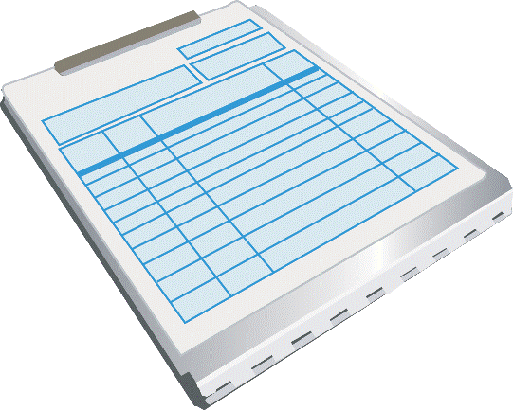
There are some special purpose loans, such as loans for marriage, tax payment, education purpose, car payment and travel. Many large retailers in Hong Kong offer consumer instalment loans. For example, when you buy a mobile phone in an electronic appliance store, you can ask for paying by instalment loans. The amount of loan a borrower can borrow depends on his/her personal financial status.

Point to note:

What is overdraft (OD)?

An overdraft occurs when a person withdraws more money than the balance of his/her bank account. Interest will be charged on the overdraft amount.

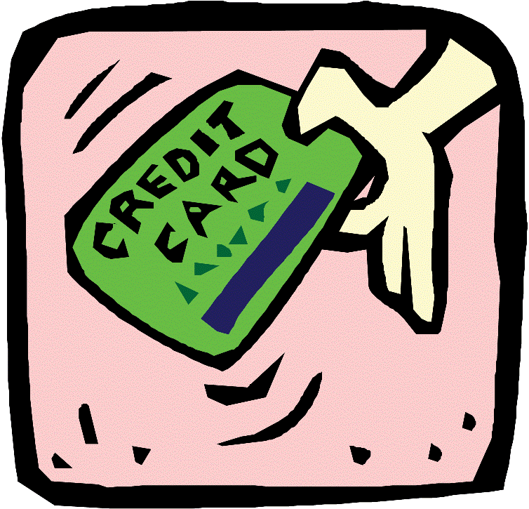

What are credit cards?
Can you name some features of credit cards?
You have to reach the age of 18 to get a credit card in your own name

Can be used for payment of goods

Paying with credit card means borrowing money from the credit card company

Any other reasonable answers

Purchases normally becomes payable within a grace period (up to 30 days) with no finance charge imposed.
The balance due may be paid in full or paid down in monthly instalments of principal plus interest.

Credit card interest rates, annual fees, and repayment terms may vary.
A plastic card with a pre-approved credit limit

Cash advance is a common feature for credit card. Interest would be charged from the date of transaction.

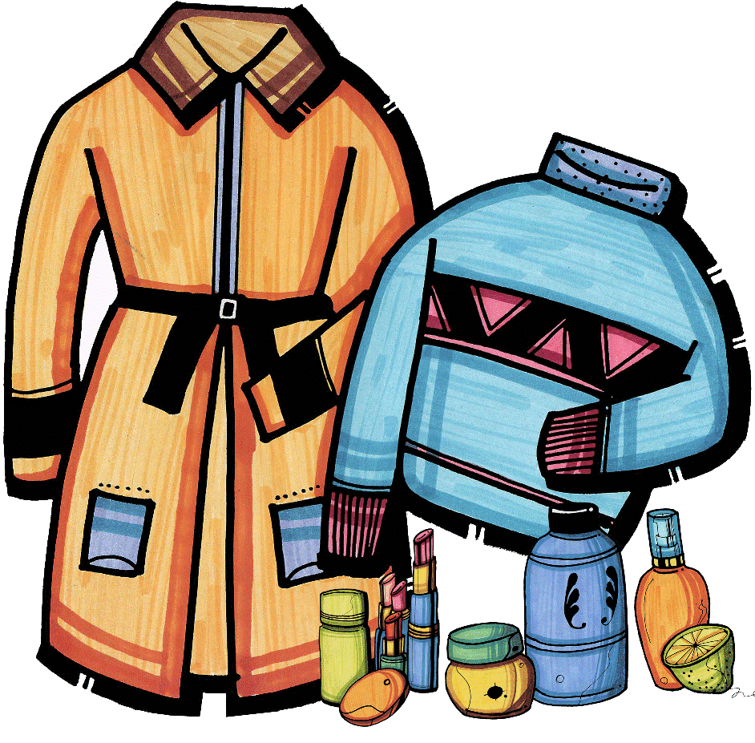

Use credit cards wisely
Do you know why people like using credit cards for making payment? What are the differences for paying by credit cards or by cash? Discuss with your classmates on the advantages and disadvantages of using credit cards.

Advantages

Convenience, easy to get and easy to use
Free credit for a period of time
Buy now pay later
No interest is charged if settled before the payment due date
Other benefits such as discounts, mileage and bonus points
Etc.

Disadvantages

Very high finance cost, interest for outstanding balance is commonly charged over 20% per annum
Easy to be over-used, sometimes due to excessive and/or unnecessary consumption
High level of theft and fraud
Etc.

In this part, teachers are only required to discuss the general features of a credit card statement. Teachers are suggested not to go into the details of each item, like the amount of minimum payment.
Homework
Ask your parents to have a credit card statement of any bank. Look at the statement and answer the following questions.

1. What is the due date of the payment? _______________________

2. How many items were paid by credit card? _______________________

3. How much was spent on credit? _______________________

4. What is the minimum payment required? _______________________

5. What is the annual rate of interest being charged? _______________________
6. If you only pay the minimum payment, what will be the finance charge to be paid next month? (Hint: <Total amount of payment – Minimum payment>*monthly periodic rate)

Terminology
Credit limit: Maximum amount of purchase and/or cash advance a credit card holder may be used on the credit card.
Grace Period: Period of time allowed for credit card holders to settle the account without penalized for a finance charge.



Personal Credit Record
Personal credit record provides personal credit history. When determining one’s creditworthiness, this credit record will be used. So, it is necessary to maintain a good personal credit record.
Have you ever borrowed money from your parents? When will you repay the money? Have you set a date for the repayment?



In Hong Kong, there are credit reference agencies (CRAs) providing services on collecting personal credit data and taking records. After analyzing the data and records, a credit score will be assigned to each individual and for the use of approving one’s consumer credit. A credit score refers to the credibility of an individual to repay the loan. Here is the scale of credit score:

(Lowest Score) J I H G F E D C B A (Highest Score)

Class Discussion
How to build up a good personal credit?
Repay every instalment on time
Think twice and set a saving plan and/or repayment schedule before consumption
Be disciplined when using consumer credits

Never buy things that are not affordable
Make sure you have the ability for repayment
Be responsible for own debts

Reasons for maintaining a good personal credit record:
Your application to the next loan may become easy.
Financial institutions may offer a higher rate or even reject an application for a loan by those who had a bad credit record.
Better rates and terms of condition may receive.
The speed for approval of loan application may be faster.
Etc

- Money is an asset that is generally acceptable as a medium of exchange and can be used for settling payments or debts.

- Saving money in the bank can earn interest. Interest is the amount of money that the bank pays you when they use the money that you keep in the bank.

- A cheque is a substitute for cash for settling debts or making payments. Paying with a cheque is easier and safer than carrying “real” money.

- There are three major types of personal finance products: mortgages, personal loans and credit cards.

- Mortgage is a long-term loan that is used for buying a property only.

- Personal loans are types of unsecured loans and always repaid by fixed instalments.

- Credit card is a plastic card with a pre-approved credit limit. Purchases by using credit card normally become payable after a grace period (up to 30 days) with no finance charge imposed.

- Personal credit record provides personal credit history. When determining one’s creditworthiness, this credit record will be used. It is necessary to maintain a good personal credit record.

