BAFS Compulsory Part - Business Environment
Topic C01: Hong Kong Business Environment - Impacts of Globalization on Business

Activity 1: Pre-study - Businesses of Four Large Corporations

You are required to –
- browse the websites of four large corporations given below to grasp a general idea on their businesses in terms of the following –
- where is its headquarter located
- where are its branches located
- what to produce
- how to produce
- for whom to produce
- where to produce

Brand | Website_English | Website_Traditional Chinese | Your source of reference  (if applicable)
Uniqlo | https://www.fastretailing.com/eng/group/strategy/uniqlobusiness.html | (English version only)
Nike | https://en.wikipedia.org/wiki/Nike,_Inc. | https://zh.wikipedia.org/zh-hk/%E8%80%90%E5%85%8B
IKEA | https://en.wikipedia.org/wiki/IKEA | https://zh.wikipedia.org/zh-hk/%E5%AE%9C%E5%AE%B6%E5%AE%B6%E5%B1%85
 | https://www.hunker.com/13710050/where-is-ikea-furniture-manufactured | (English version only)
Apple | https://en.wikipedia.org/wiki/Apple_Inc. | https://zh.wikipedia.org/zh-hk/%E8%98%8B%E6%9E%9C%E5%85%AC%E5%8F%B8

- complete Student Worksheet p.2-3 and/or give your source(s) of reference if applicable;
- share your study in the next lesson.

BAFS Compulsory Part - Business Environment
Topic C01: Hong Kong Business Environment - Impacts of Globalization on Business

Activity 1: Pre-study - Businesses of Four Large Corporations

Brand | Where is its headquarter located | Where are its branches located (e.g.) | What to produce | How to produce | For whom to produce | Where to produce (e.g.)
Uniqlo
Nike

IKEA
Apple

BAFS Compulsory Part - Business Environment
Topic C01: Hong Kong Business Environment - Impacts of Globalization on Business

Activity 2: Group Discussion

Discuss and write down the positive and negative impacts of Globalization.

Positive Impacts

Negative Impacts

BAFS Compulsory Part - Business Environment
Topic C01: Hong Kong Business Environment - Impacts of Globalization on Business

Activity 3: Student Reflection

Share your view on the impacts of globalization on Hong Kong’s business environment.

BAFS Compulsory Part - Business Environment
Topic C01: Hong Kong Business Environment – Increasing International Trade Cooperation

Activity 4: Pre-study – What are the WTO and APEC ?

You are required to –
- browse the websites given to grasp a general idea on the two international trade organisations, i.e. World Trade Organisation (WTO) and Asia-Pacific Economic Cooperation (APEC), in terms of the following –
- What it is
- What to achieve
- What to do
- Membership
- Hong Kong’s participation in the organisation

 | Website_English | Website_Traditional Chinese | Your source of reference  (if applicable)
WTO | https://www.tid.gov.hk/english/ito/wto/index.html | https://www.tid.gov.hk/tc_chi/ito/wto/index.html
 | https://www.wto.org/index.htm (English only)
APEC | https://www.tid.gov.hk/english/ito/apec/index.html | https://www.tid.gov.hk/tc_chi/ito/apec/index.html
 | https://www.apec.org/ (English only)

- complete Student Worksheet p.8-9 and/or give your source(s) of reference if applicable;
- share your study in the next lesson.

BAFS Compulsory Part - Business Environment
Topic C01: Hong Kong Business Environment – Increasing International Trade Cooperation

Activity 4: Pre-study – What are the WTO and APEC ?

About the organisation | World Trade Organisation (WTO) | Asia-Pacific Economic Cooperation (APEC)
What it is
What to achieve
What to do
Membership
Hong Kong’s participation in the organisation

BAFS Compulsory Part - Business Environment
Topic C01: Hong Kong Business Environment - Increasing International Trade Cooperation
Activity 5: Matching Game & Quiz

Part (1): Match the descriptions with the appropriate organisations.

(A) The only international organisation that deals with the global rules of trade between nations |  |  |  | (F) The consensus-based procedures are adopted but not legally binding
(B) The agreements cover goods, services and intellectual property |  | WTO  世界貿易組織 |  | (G) There are no binding commitments or treaty obligations. Commitments are undertaken on a voluntary basis
(C) All major decisions are made by consensus and are binding legally |  |  |  | (H) A forum for 21 Pacific Rim countries on the basis of non-binding commitments to enhance free trade and investment in the Asia-Pacific region
(D) To support sustainable economic growth and promote economic cooperation in the Asia-Pacific region |  | 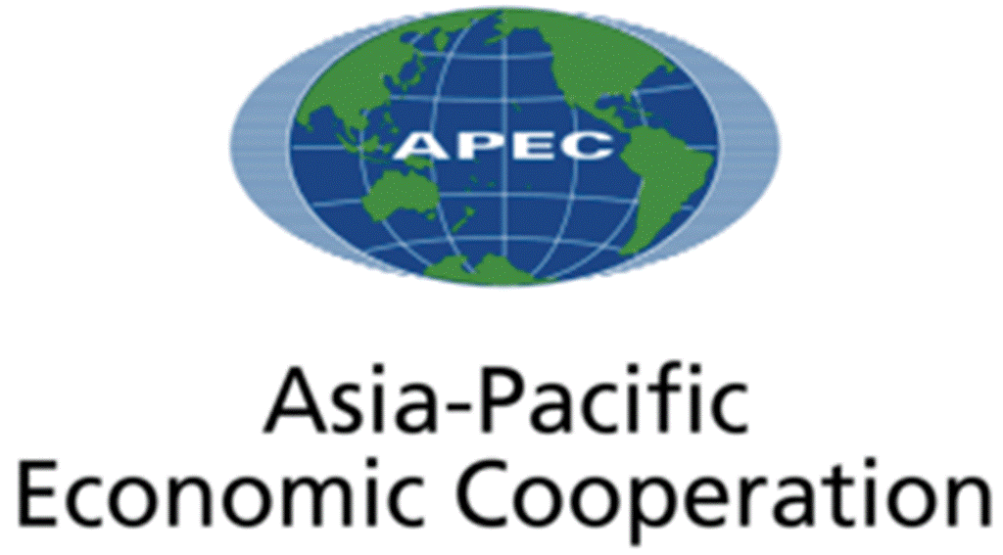  APEC  亞太經濟合作組織 |  | (I) Enforcement of the rules of trade through negotiation accompanying with a mechanism for settling disputes
(E) To make trading rules to ensure trade flows as freely, smoothly and predictably as possible |  |  |  | (J) To help global businesses, especially micro, small and medium sized businesses resolve business-to-business cross-border disputes using online dispute resolution

Part (2): Quiz – Choose the best answer

- Which of the following is not the work/function of World Trade Organisation?

- To establish fund for provision of financial support to member nations.
- To set up ground-rules for the member nations to conduct trade policies according to those rules.
- To offer special provision to help developing countries develop the skills and infrastructure needed to expand their trade.
- To provide a mechanism for settling trade disputes among member nations.

- Which of the following is not the work/function of Asia-Pacific Economic Cooperation?

- It reduces tariff and non-tariff barriers to trade and investment that boosts job creation, incomes and growth.
- It pursues measures to reduce the time, cost and uncertainty of doing business in the region.
- It builds the technical capacity of member economies to promote trade, investment and economic growth.
- It enforces treaty obligations among the member economies.

- Which of the following statement is the best description of Hong Kong’s participation in WTO?

- To deal with economic issues such as the economic integration and money supply of member countries.
- To improve logistics and transport networks in member countries.
- To support the multilateral trading system enforced by WTO.
- To prevent trade deficits of member countries.

- Which of the following statement is the best description of Hong Kong’s participation in APEC?

- To provide a platform for trade negotiation among countries in the Asia-Pacific Region.
- To build a close economic and trade linage with other member economies in the region.
- To provide low-interest loans to developing countries in the Asia-Pacific Region.
- To foster monetary cooperation and secure financial stability among countries in the Asia-Pacific Region.

