BAFS Compulsory Part - Business Environment
Topic C01: Hong Kong Business Environment - Impact of Globalization on Business

Activity 1: Pre-study - Businesses of Four Large Corporations

Suggested Answers

Brand | Where is its headquarter located | Where are its branches located (e.g.) | What to produce | How to produce | For whom to produce | Where to produce (e.g.)
Uniqlo | Japan | - China  - South Korea  - Southeast Asia  - South Asia  - North America  - Europe  - Britain | Comfy LifeWear with universal design | - Research & Development (R&D) to respond to customers’ requests  - high-volume supplies of top-quality materials at low cost by negotiating directly with materials manufacturers worldwide | LifeWear made for everyone, everywhere | - China  - Vietnam  - Bangladesh  - Indonesia  - India
Nike | US | Contracted with more than 700 shops around the world and has offices located in 45 countries outside the US | - Athletic footwear & apparel  - Athletic & recreational products  - Sports equipment | - Contract to independent factories worldwide to make Nike products  - R&D (include to partnering Apple Inc., University of Oregon, etc.) to improve performance of its products | - Professional athletes  - Those taking regular physical fitness/activity | - Indonesia  - China  - Taiwan, China  - India  - Thailand  - Vietnam  - Pakistan  - Philippines  - Malaysia
IKEA | Netherland | 422 IKEA stores operating in 50 countries (as of March 2021) around the world | Eco-friendly and modern designed ready-to-assemble furniture, kitchen appliances and home accessories | - Use/consume the world commercial wood and apply an integrated approach to manufacture and design to achieve and maintain the sustainability of wood resources  - Most furniture is designed to be assembled by the customer so as to reduce costs  - Use of packaging by not shipping air | - Young adult/ professionals  - Young middle class  (of ages ranging from 16 to 34) | - China  - Developing countries such as Vietnam, Malaysia and Myanmar  - Eastern European countries such as Romania and Poland
Apple | US | - Cork (Ireland)  - Herzliya (Israel)  - London  - New York  - Pittsburgh  - San Diego  - Seattle, etc. | Specialise in consumer electronics, software and online services | - As of 2021, Apple uses components from 43 different countries  - Its manufacturing, procurement, and logistics are operated in a way that enable it to execute massive product launches without having to maintain large, profit-sapping inventories | Medium to high-income households or individuals, e.g. college students, executives, managers, professionals | The majority of assembling is done by original design manufacturer firms (e.g. Foxconn). Their factories mostly are located inside China, but also Brazil and India

BAFS Compulsory Part - Business Environment
Topic C01: Hong Kong Business Environment - Impacts of Globalization on Business

Activity 2: Group Discussion

Discuss and write down the positive and negative impacts of globalization.

Refer to PPT#11-12 for details of the suggested answers
BAFS Compulsory Part - Business Environment
Topic C01: Hong Kong Business Environment - Impact of Globalization on Business

Activity 3: Student Reflection

Suggested Answers

Share your view on the impacts of globalization on Hong Kong’s business environment.

Capital: (e.g.) Hong Kong is a portal for foreign corporations to raise capital by listing their stocks in HKEx.
Hong Kong corporations also can trade on stock exchanges in other countries, e.g. US, to raise capital.
Trade and market: (e.g.) Companies of HKSAR are not restricted to the local market but expand their
businesses to different countries/regions, such as China, US, Europe, East Asia. However,
companies of HKSAR have to face a keen competition from foreign companies as a result of free trade and market.
Production: (e.g.) Services industries are the key pillar to support the economic growth in Hong Kong.
Some of them outsource part of support functions of their companies to lower cost countries/regions, e.g.
a number of banks/insurance companies in Hong Kong outsource customer hotline/enquiry services to
Guangzhou to lower their operational cost.
Information: (e.g.) Hong Kong is equipped with world-class infrastructure, constituting highly efficient local
and regional transportation networks and advanced air and sea freight systems, as well as digital and
telecommunications facilities which are among the best in the world. These facilities enable efficient flows
of people, goods and information between Hong Kong and the rest of the world, and enhance our
commercial connectivity with various regions.
People: (e.g.) Hong Kong has a well-educated labour force, especially local professionals who are highly
regarded and of international standards. Therefore, Hong Kong is trusted by business partners worldwide,
especially in the Mainland market, to help foreign enterprises tap into the Mainland market and Mainland
enterprises go Global.

BAFS Compulsory Part - Business Environment
Topic C01: Hong Kong Business Environment – Increasing International Trade Cooperation

Activity 4: Pre-study – What are the WTO and APEC ?

Suggested Answers

About the organisation | World Trade Organisation (WTO) | Asia-Pacific Economic Cooperation (APEC)
What it is | - The WTO is the only international body dealing with the rules of trade among states and separate customs territories.  - The WTO agreements provide the legal ground-rules for international commerce, binding governments to conduct their trade and trade policies according to the principles and rules. | - Asia-Pacific Economic Cooperation (APEC) is an informal forum set up in 1989 for high level government-to-government dialogue on trade and economic issues.  - APEC operates on the basis of non-binding commitments, open dialogue and equal respect for the views of all participants, meaning it has no treaty obligations required of its participants. Decisions within APEC are reached by consensus and commitments are undertaken on a voluntary basis.
What to achieve | Its goal is to make trading rules to ensure trade flows between producers and providers of goods and services, exporters and importers as smoothly, predictably and freely as possible*  *Trade Policy Review mechanism is adopted to achieve greater transparency in the trade objectives, policies and practices of individual WTO Members, thereby facilitating the smooth functioning of the multilateral trading system. | It aims to create greater prosperity for the people of the Asia-Pacific region by promoting balanced, inclusive, sustainable, innovative and secure growth and by accelerating regional economic integration.
What to do | To achieve its goal, the WTO –  - provides a fair, predictable and open rule-based trading system through overseeing the implementation of multilateral trade rules and enforcing legally binding obligations, so as to ensure member nations’ commitments to lower customs tariffs and other trade barriers, and to open and keep open services markets  - makes member nations’ trade policies transparent in compliance with the multilateral trade negotiations enforced by the WTO  - provides a mechanism for settling trade disputes and integrates developing and least developed economies into the world trading system  - offer special provision to help developing countries develop the skills and infrastructure needed to expand their trade | APEC works towards the realisation of its goal in the following ways^{*2} –  - Reduces tariff and non-tariff barriers to trade and investment that boosts job creation, incomes and growth  - Pursues measures to reduce the time, cost and uncertainty of doing business in the region and open new economic opportunities including for small firms, women and youth  - Builds the technical capacity of APEC’s diverse members to promote trade, investment and robust, secure and sustainable economic growth that widely benefits the region’s people
Membership | The WTO currently has 164 members, accounting for over 95% of world trade^{*1}. | APEC has 21 member economies^{*3} as at 2020.
Hong Kong’s participation in the organisation | - Hong Kong is one of the founding members of the WTO and participates in the WTO as a full and separate member, using the name “Hong Kong, China” (HKC).  - HKC enjoys a high degree of autonomy in the conduct of its external commercial relations under the WTO.  - HKC is the first WTO Member to join the Agreement on Trade Facilitation (TFA) in 2014 which is the first multilateral trade agreement concluded by the WTO and enforced in 2017 | - Hong Kong joined APEC in 1991.  - The Director-General of Trade and Industry is HKC’s Senior Official to APEC and the Trade and Industry Department takes a leading role in HKC's participation in the APEC fora.  - Recently, HK is one of the APEC-wide cooperative online dispute resolution (ODR) framework providers to help global businesses, in particular, micro-, small-, and medium-sized enterprises (MSMEs) resolve low-value disputes across borders by providing speedy and cost-effective dispute resolution with the use of digital technology.

Remarks:
^{*1} Details of membership of WTO (English only): https://www.wto.org/english/thewto_e/whatis_e/tif_e/org6_e.htm
^{*2} APEC website – Home > How APEC Operates > Scope of Work (English only):
https://www.apec.org/about-us/how-apec-operates/scope-of-work
^{*3} Details of the membership of APEC (English only):
https://www.apec.org/About-Us/About-APEC/Member-Economies

BAFS Compulsory Part - Business Environment
Topic C01: Hong Kong Business Environment - Increasing International Trade Cooperation

Activity 5: Matching Game & Quiz
Suggested Answers

Part (1): Match the descriptions with the appropriate organisations.

(A) The only international organisation that deals with the global rules of trade between nations |  |  |  | (F) The consensus-based procedures are adopted but not legally binding in making decisions/agreements
(B) The agreements cover goods, services and intellectual property |  | 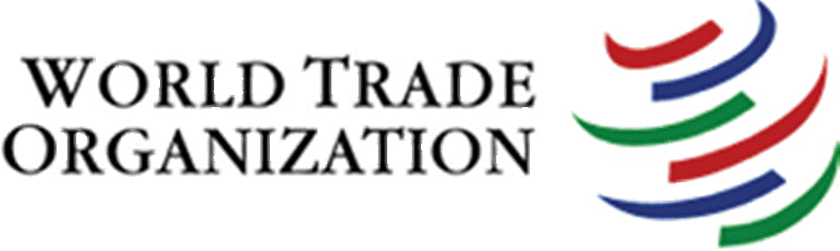  WTO  世界貿易組織 |  | (G) There are no binding commitments or treaty obligations. Commitments are undertaken on a voluntary basis
(C) All major decisions are made by consensus and are binding legally |  |  |  | (H) A forum for 21 Pacific Rim countries on the basis of non-binding commitments to enhance free trade and investment in the Asia-Pacific region
(D) To support sustainable economic growth and promote economic cooperation in the Asia-Pacific region |  | 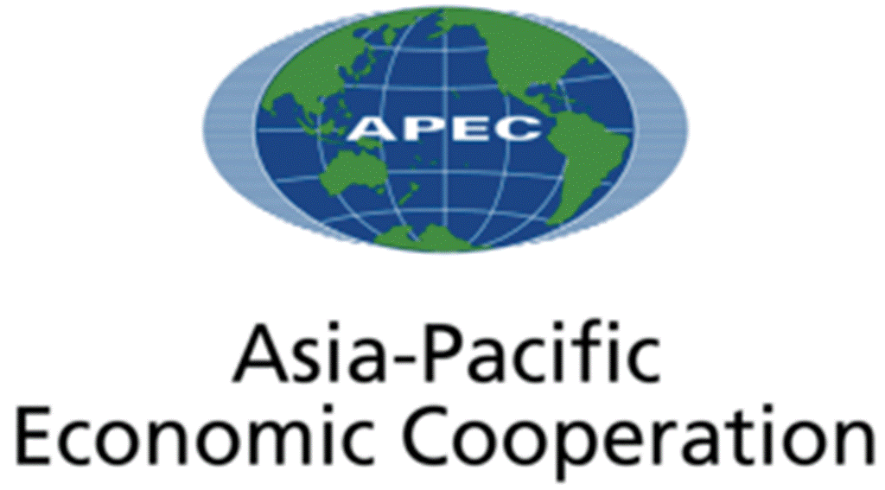  APEC  亞太經濟合作組織 |  | (I) To enforce the rules of trade through negotiation and a mechanism for settling disputes
(E) To make trading rules to ensure trade flows as freely, smoothly and predictably as possible |  |  |  | (J) To help global businesses, especially micro, small and medium sized businesses resolve business-to-business cross-border disputes using online dispute resolution

Suggested Answers

Part (2): Quiz – Choose the best answer

- Which of the following is not the work/function of World Trade Organisation?

- To establish fund for provision of financial support to member nations.
- To set up ground-rules for the member nations to conduct trade policies according to those rules.
- To offer special provision to help developing countries develop the skills and infrastructure needed to expand their trade.
- To provide a mechanism for settling trade disputes among member nations.
Suggested answer: A

- Which of the following is not the work/function of Asia-Pacific Economic Cooperation?

- It reduces tariff and non-tariff barriers to trade and investment that boosts job creation, incomes and growth.
- It pursues measures to reduce the time, cost and uncertainty of doing business in the region.
- It builds the technical capacity of member economies to promote trade, investment and economic growth.
- It enforces treaty obligations among the member economies.
Suggested answer: D

- Which of the following statement is the best description of Hong Kong’s participation in WTO?

- To deal with economic issues such as the economic integration and money supply of member countries.
- To improve logistics and transport networks in member countries.
- To support the multilateral trading system enforced by WTO.
- To prevent trade deficits of member countries.
Suggested answer: C

- Which of the following statement is the best description of Hong Kong’s participation in APEC?

- To provide a platform for trade negotiation among countries in the Asia-Pacific Region.
- To build a close economic and trade linage with other member economies in the region.
- To provide low-interest loans to developing countries in the Asia-Pacific Region.
- To foster monetary cooperation and secure financial stability among countries in the Asia-Pacific Region.
Suggested answer: B (Option A is also correct but Option B is the most important contribution for Hong Kong to join APEC)

